CHALLENGE YAHTZEE SCORE SHEET
NAME OF PLAYER
SCORE CARD

UPPER SECTION HOW TO SCORE GAME
#1
GAME #2
GAME #3
GAME #4
GAME #5
GAME #6

Aces = 1 | Count and Add Only Aces
Twos 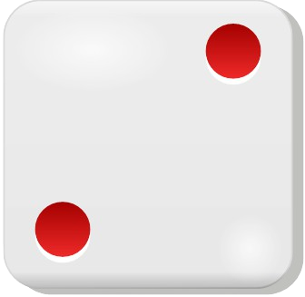 = 2 | Count and Add Only Twos
Threes 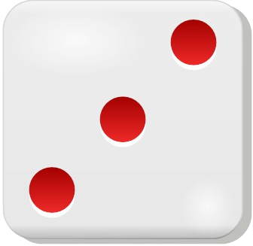 = 3 | Count and Add Only Threes
Fours 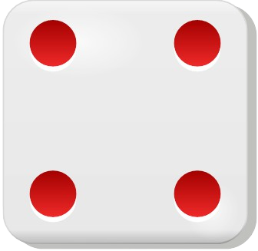 = 4 | Count and Add Only Fours
Fives 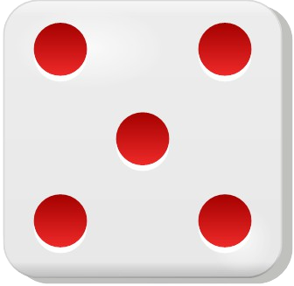 = 5 | Count and Add Only Fives
Sixes 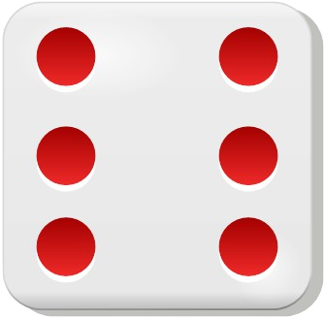 = 6 | Count and Add Only Sixes
TOTAL SCORE
BONUS If total score  is 63 or over | SCORE 35
TOTAL Of Upper Section
LOWER SECTION | HOW TO SCORE
3 of a kind | Add Total of All Dice
4 of a kind | Add Total of All Dice
Full House | SCORE 25
Sm. Straight (4 in order) | SCORE 30
Lg. Straight (5 in order) | SCORE 40
YAHTZEE (5 of a kind) | SCORE 50
Chance | Score Total of All 5 Dice
YAHTZEE BONUS | √ FOR EACH BONUS
 | SCORE 100 PER √
TOTAL Of Lower Section
TOTAL Of Upper Section
GRAND TOTAL

